K-Rec Konnect - Family Information Sheet

Please review these policies and if you have any questions, please do not hesitate to contact us at the Parks & Recreation Department Office: (781) 585-0533.
Policies subject to change if state guidelines and protocols change.
~ Parents/Guardians will be notified through email and text blast for any program changes ~

Children MUST bring their own water bottle. If they do not have it with them they will be asked to go with their families to go get their water bottle and return. We will not be providing cups, in order to assist with sanitization situations, and it is imperative that all children have a water bottle. A touch free water system has been installed in the building for each child to refill their water bottle when necessary.

Drop Off:
Counselors will not be ready to watch children prior to the scheduled drop-off time as they have meetings discussing that day’s activities. DO NOT drop off children unattended.
Parents/Guardians will be required to walk down with their children to the designated check in area for their groups and sign in with their counselors. This includes all ages (including your 7th & 8th graders). Do not drop off children or let them walk down alone and leave them unattended.
Pick –Up:
- Parents/Guardians are required to walk down and sign out their children with their counselor at their designated area.
- If your child(ren) will be picked up by someone other than the parent/guardian, a note MUST be provided to the Lead Counselor in the morning at drop off. Phone calls and e-mails are not acceptable, as there are too many participants to manage in that capacity. We are not always at our desks to access e-mails.

Daily Information:
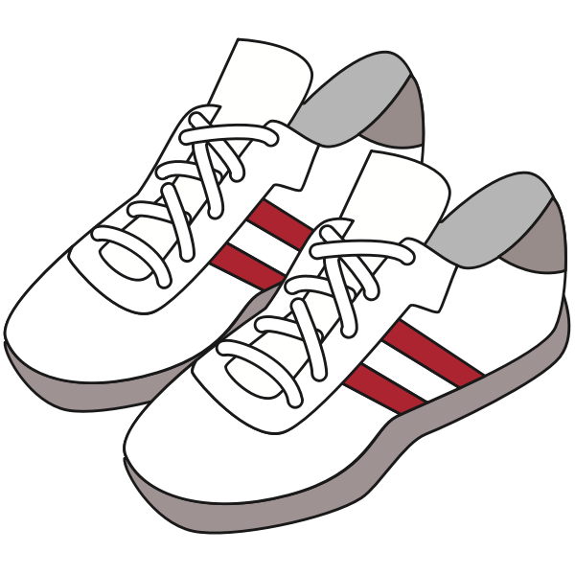
- Children must bring a water bottle daily.
- Children must wear sneakers for activities.
- Children should not bring any food, unless needed for medical reasons; or if staying for extended day.
- Extended day participants bring their lunch and a snack. Lunches will be dropped off by families at designated area in lower hall
- NO cell phones or electronic devices allowed. This causes too much controversy amongst participants, as well as the possibility for items to be lost or broken during activities.

Heat Advisory Policy:
In the event of a Heat Advisory, programs for that day will be cancelled.

Rainy Day Policy:
In the event of a rainy day, we will coordinate activities inside for that day – but activities will be limited due to space constraints.

As a reminder, below is the Disclaimer You Electronically Signed when you registered your child –

By confirming acknowledgement, I understand there are risks of physical injury in participating in events, activities, or programs.
I hereby release and hold harmless the Town of Kingston, its employees, officials, and agents from any and all injuries, illnesses, exposure, damages, suits, claims, losses or liability of any kind that my child or I may experience in connection with activities sponsored by the Town of Kingston, or when using properties owned by the Town of Kingston.
I hereby consent to emergency medical procedures deemed advisable for myself if I am not able to speak on my own behalf, or my child in the event I cannot be reached, and my child has sustained an injury. The Town of Kingston does not provide accident or hospitalization insurance for participants of its programs. All participants are advised to have adequate personal coverage. Please consider participant's own health, experience, and tolerance for risk before participating in any program. I also consent to the use of my or my child’s photo, video, artwork etc. by the Town of Kingston for flyers, presentations etc.

Ready For the Summer!
Susan Woodworth, Director of Parks and Recreation
Brandi Gordon, Recreation Office Program Administrator
Katie Hall & Kirstyn Tanous, Summer Program Directors

